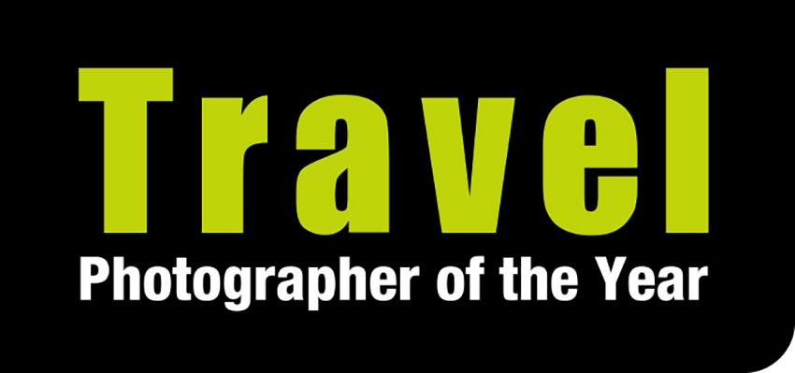
To request images for publication, please download our image request/caption document here. This contains individual image numbers for each of the images on our Winners Gallery https://www.tpoty.com/galleries/2021-winners Please email karen@tpoty.com with your choice of image numbers. Images are provided for editorial use only and must be used for news items, features or galleries about the Travel Photographer of the Year awards and/or its exhibitions. The photographers and tpoty.com must be credited. Please view our image usage restrictions here and confirm that you will adhere to them when you request pictures for publication.

24 January 2022 – for immediate release

RETURNING TO A WORLD OF TRAVEL
The winners of the 2021 Travel Photographer of the Year awards are revealed

- Overall Winner: Travel Photographer of the Year 2021 – Fortunato Gatto, Italy
- Young Travel Photographer of the Year 2021 – Jai Shet, USA (age 18)
- Young Travel Photographer of the Year: Winner, 15-18 yrs – Tevin Kim, USA (age 16)
- Young Travel Photographer of the Year 2020: Winner, 14 yrs & under – Indigo Larmour, Ireland (age 13)
- Portfolio Winner: Best 8 – Alessandro Bergamini, Italy
- Portfolio Winner: Landscapes & Adventures – Jie Fischer, USA
- Portfolio Winner: Living World – William Burrard-Lucas, UK
- Portfolio Winner: People & their Stories – Beniamino Pisati, Italy
- One Shot Winner: As Shot – Mouneb Taim, Syria
- One Shot Winner: Green Planet – Johnny Haglund, Norway
- One Shot Winner, Icons of Travel – Alain Schroeder, Belgium
- Smart Shot Winner: iTravelled – View Van Tran, Vietnam
- People’s Choice Winner: Dani Salvà, Spain
- HD Video Winner, Travel Shorts: Philip Lee Harvey, UK
_______________________________________________________________________

From beguiling abstract images of the ‘paintings’ created by the sand and tides in the Scottish Hebrides to a Ramadan breakfast amidst the devastation of a Syrian town, intimate and fascinating depictions of lives and cultures across the globe, a hare in ‘ball’ of ice and snow and a ‘ghost leopard’ apparently merging with the stars, the winning images in the 2021 global Travel Photographer of the Year awards (TPOTY) present a diverse and glorious view of life on our planet.

The global spread of the awards can be seen in the fact that some 20,000 images were submitted from photographers in 151 countries. The winning shots – which can all be viewed in the online Winners’ Gallery on tpoty.com - will go on display a spectacular, free-to-view outdoor exhibition in a magnificent London venue – Granary Square near King’s Cross and St Pancras stations, in April and May 2022.

TPOTY founder Chris Coe said: ““The last two years have been tough for everyone and opportunities for travel photographers to shoot new imagery have been limited. Despite this, TPOTY has managed to keep attracting great imagery and we have kept our exhibitions running in safe outdoor spaces. The winning images and those received from all entrants, are testament to the tenacity, creativity and ingenuity of travelling photographers. 2022 is TPOTY’s 20th award and we look forward to celebrating even more of the best travel-related photography from around the world.”

The Overall Winner – the Travel Photographer of the Year 2021 – is Fortunato Gatto. This Italian photographer has been based in Scotland since 2007, and his deep love of his adopted country is reflected in his sumptuous, detailed abstract images of patterns in the sand in the Hebrides which form part of his winning selection. In addition, his images of a ‘meeting of the seasons’ in Alaska draw you in, with a wonderful sense of place, to one of earth’s most beautiful remote places.

Two fledgling photographers from America caught the judges’ eye in the Young TPOTY contest. 18-year-old Jai Shet’s beautiful series of forest images capturing the seasons won him the title of Young Travel Photographer of the Year, while his fellow American, 16-year-old Tevin Kim, won the 15-18 Year category for images of homes and barns in ‘Mormon Row’, Wyoming. And 13-year-old Indigo Larmour from Ireland features in the Young TPOTY roll of honour for the third year in succession, this time taking top honours in the 14 and Under category with a dynamic portfolio capturing camel racing in Sharjah.

Fortunato Gatto’s prize included a Fujifilm X-T4 cameras with lens, a £1000 cash bursary from TPOTY, a personalised leather portfolio book or iFolio from Plastic Sandwich, a LEE Filter kits, print and digital copies of JRNY travel magazine, and membership of the Royal Photographic Society. Jai Shet receives £500 from TPOTY, a Plastic Sandwich leather portfolio book or iFolio, a place on a Photo Iconic Photography course plus a year’s Royal Photographic Society membership and a digital copy of JRNY travel magazine.

Another Italian photographer – Alessandro Bergamini – won the Best 8 portfolio category with eight images that gave great insight into the lives and communities of his subjects in Afghanistan, China, India, Myanmar and Russia. Belgian Alain Schroeder’s action-packed black and white image of hundreds of men on horseback fiercely competing to win a game of ‘dead goat polo’ in Kyrgyzstan was voted the Best Single Image winner of the Best 8 category.

US photographer Jie Fischer was the winner of the Landscape & Adventure category with a colourful, almost abstract portfolio depicting flamingos over the remarkable coloured waters of Lake Magadi in Kenya. Professional ski photographer Pally Learmond (UK) won the Best Single Image award with his striking image of a freeskier on ‘Dirty Needle’ mountain, Alaska.

The Living World category was won by British photographer Will Burrard-Lucas, using his self-developed Camtraptions camera trap system to capture images of leopards – including rare melanistic leopards - at night in Kenya, with one particular long exposure shot combined with flash making the leopard appear to emerge from the stars. The Best Single Image award in this category went to Portuguese photographer Jose Fragozo, whose patience and knowledge of hippos enabled him to capture the precise moment one of these powerful creatures opened its eye as it rose from a mud pool.

Yet another Italian photographer took a top award, when Beniamino Pisati won the People & Their Stories category with his black and white portfolio documenting the lives of milk and cheese producers in the mountains of Lombardy. Irish photographer Trevor Cole received the Best Single Image award here for his unusual portrait of a young cattle herder in South Sudan.

Portfolio category prizes included Fujifilm X-T4 cameras with lenses, an international photography adventure with Chris Weston Photography, Genesis Imaging exhibition prints, LEE Filter kits, print and digital copies of JRNY travel magazine, and membership of the Royal Photographic Society.

In the single image categories, Alain Schroeder took first and second places in Icons of Travel, with his image of the Mansudae Grand Monument in Pyongyang, North Korea taking first prize. Norwegian Johnny Haglund’s image of waste pollution in Belèm, Brazil was the graphic and poignant winner of the Green Planet category at a time when man’s impact on the planet is in the spotlight, and Syrian photojournalist Mouneb Taim received first prize in the As Shot category for his drone shot of a mass Ramadan breakfast held in the ruins of a bomb-damaged Syrian town. The iTravelled category for images shot on a mobile phone or tablet was won by Vietnamese photographer Viet Van Tran, for his colourful, beautifully composed image of a 90-year-old shoemaker in Saigon.

Single image prizes included cash bursaries, a signed, framed limited-edition print by Chris Weston from Animals on the Edge print and digital copies of JRNY travel magazine, and membership of the Royal Photographic Society.

The winner in one category was not chosen by the judges. The People’s Choice award was decided by members of the public voting on the TPOTY website. The winning image, chosen from 10,419 votes, is by Spanish photographer Dani Salvà and shows preparations for the ‘Dance of Death’ in Verges, Spain.

Finally, British photographer and filmmaker Philip Lee Harvey won the Travel Shorts video category, with an uplifting video showing the fantastic results of the work of Spotlight on Africa, training seamstresses in Musoto, Uganda.

The awards are judged by an international panel of vastly experienced photographers and experts in the field. All judging is completed ‘blind’ – the judges do not know the identity or nationality of any entrants – and finalist must provide the RAW/original image files for the final judging stage.

Ends

For media enquiries and images please contact Karen Coe at Travel Photographer of the Year on +44
(0) 7540 725821 or email karen@tpoty.com
To request images for publication, please download our image request/caption document here. This contains individual image numbers for each of the images on our Winners Gallery https://www.tpoty.com/galleries/2021-winners Please email karen@tpoty.com with your choice of image numbers. Images are provided for editorial use only and must be used for news items, features or galleries about the Travel Photographer of the Year awards and/or its exhibitions. The photographers and tpoty.com must be credited. Please view our image usage restrictions here and confirm that you will adhere to them when you request pictures for publication.

