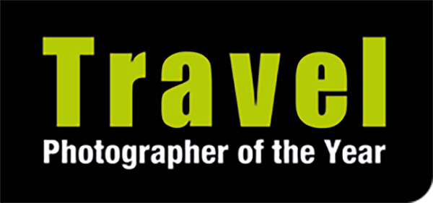

4 April 2023 – for immediate release

‘INSPIRING PHOTOGRAPHY’
Travel Photographer of the Year brings leading international photographers together for an inspiring weekend of talks at the Royal Photographic Society (May 27 & 28)

In conjunction with the Royal Photographic Society (RPS), Travel Photographer of the Year is bringing together an international group of professional photographers and imaging experts for ‘Inspiring Photography’, an enormously informative and enjoyable weekend of photography talks and panel discussions at the RPS in Bristol on 27 and 28 May. A wide range of photographic genres will be covered, including landscapes & aerial, wildlife & conservation, people & cultural, travel, adventure & expedition, and documentary photojournalism. There will also be talks on the evolution of photography, collecting prints and how to win competitions, along with portfolio reviews.

‘Inspiring Photography’ takes place against the background of a superb, free-to-view outdoors exhibition of the latest winning images in the global Travel Photographer of the Year awards (TPOTY), which runs from 29 April to 6 June at the RPS.

‘Inspiring Photography’ presenters include the current Travel Photographer of the Year Matjaz Krivic, adventure and expedition photographer Martin Hartley, travel photographer, digital imaging expert and educator Elia Locardi, nature, landscape and aerial photographer Marek Biegalski, cultural and people photographer Trevor Cole, photojournalist Kiran Ridley and wildlife photographer Chris Weston.

Ticket holders will also have the opportunity to book in advance portfolio reviews and have their own work critiqued by the experts. In addition, all participants will have the chance to meet the speakers and presenters for an informal chat at the end of each day. And all ticket holders will receive a 40% discount code for their first order with Genesis Imaging, to be used on professional photographic printing, mounting and framing services, plus a 30% discount code for Radiant Photo imaging software.

Tickets are strictly limited and are available to buy via the RPS website. A single-day ticket costs £65, a weekend pass costs £105 and portfolio reviews cost £25. There are discounts for RPS members and members of Travel Photographer of the Year’s Eye for the Light club.

The weekend programme is as follows:

Saturday 27 May
10.00 Elia Locardi: Travel Photography – creating impactful images from around the world
10.55 Martin Hartley: Adventure & expedition photography
11.50 Break
12.05 Deborah Ireland: From Daguerreotype to Digital - the history of photography
13.00 Lunch Break
13.50 Marek Biegalski: Eye level & above – landscape & drone photography
14.25 Martin Hartley, Marek Biegalski, Diana Jarvis & Chris Coe: Panel discussion on travel, landscape,
environment & responsible photography
15.25 Break
15.45 Colin Finlay: Collecting photography
16.30 Elia Locardi & Chris Coe: In-camera vs digital manipulation explained
17.30 Meet the Photographers
18.30 Close

Sunday 28 May
10.00 Trevor Cole: Photographing people – cultural & social photography
10.40 Trevor Cole, Diana Jarvis & Chris Coe: Panel discussion on respecting people & cultures through
responsible photography
11.40 Break
12.00 Kiran Ridley - Out of conflict – documenting Ukraine & its people
13.00 Lunch Break
14.00 Chris Coe, Colin Finlay, Matjaz Krivic & Kiran Ridley: Winning photo competitions
15.00 Break
15.20 Chris Weston: Wildlife & nature – can photography save the planet?
16.00 Colin Finlay, Chris Weston & Diana Jarvis: Panel discussion on wildlife & nature
photography, conservation & sustainability
17.00 Meet the Photographers
18.00 Close

Travel Photographer of the Year is one of three major international photography awards converging on Bristol under the banner of World Photography in Focus over this period.

The TPOTY exhibition will be located outdoors in the space between The Royal Photographic Society (RPS) and The Martin Parr Foundation in Bristol’s Arnos Vale, while Wildlife Photographer of the Year will be at M Shed and the Food Photography Awards inside the RPS.

For further information visit the Travel Photographer of the Year website www.tpoty.com.

- Ends –

For media enquiries and images please contact Karen Coe at Travel Photographer of the Year on
+44 7540 725821 or email karen@tpoty.com
Images are provided for editorial use only and must be used for news items, features or galleries about the Travel Photographer of the Year awards and/or its exhibitions. The photographers and tpoty.com must be credited. Please view our image usage restrictions here and confirm that you will adhere to them when you request pictures for publication.

